**Types of Flows:**

**Flow Types:**

**Process Flows**

**Screen Flows**

**Sub Flows ( Called Flows- Process Flow/Screen Flow)**

**Diff B/w Process & Screen Flows:**

**Process Flow:**

* **We can Add Work Object**
* **We Can add Multiple Flowaction's for Assignment( 1 FA is Best Practice)**
* **Flowaction Name is Given under Assignment Connector Properties**
* **Routing is Possible at Assignment Level**
* **In Process flow 1 Transaction can have multiple steps/Tasks. In Process flow every step is a separate task.**
* **We can Call Screen Flows & Process Flow in Process Flows, Calling One Process/Screen Flow in another Process flow is called Sub Flow. The Called flow will be subflow**
* **In Process flow there are no Types( Templates - Perform , New, Confirm)**
* **Process flow is the staring flow of  the application/ Starter Flows**
* **In Process Flow we have only Front Navigation**
* **In Process Flow we have basic shapes, Advanced Shapes & Automation Shapes**

**Screen Flow:**

* **We cannot Add Work Object**
* **We can Add One Flowaction for Assignment**
* **Flowaction name is given under assignment shape Properties**
* **Routing is Not Possible at Assignment Level, but it is Possible at Flow Level. Routing option is available under start shape properties.**
* **In Screen flow entire transaction is Considered as 1 Task**
* **We can Call Screen Flow in Screen flow,  We cannot call Process flow in Screen flow.**
* **We must call Screen flow in Process flow using Sub Process Shape**
* **Screen flow Contains Types/Templates ( Perform, Tabbed, TreeNavigation)**
* **In screen flows we have front & Back Navigation b.w Pages**
* **In screen flow we don't have advanced shapes.**

**Sub Process Shape:**

**- To Call one flow in another flow we can use Sub Process Shape:**

**Screen - Screen flow**

**Process - Process flow**

**Screen - Process flow**

**When to Create Screen Flows?**

**If the process flow design is having more shapes then divide the flow into sub flows then we can add screen flow.**

**If UI design requires Front & Back navigation b/w pages then create using Screen flow**

**Req:  Add User Screen flow & Redesign Process flow.**

**- Customer Details, Transaction Details & Auto Vehicle details must be entered by the User. So Design these screens using Screen Flow & Call Screen flow in Insurance Process flow using Sub Process shape**

**- Also Include Customer Search Functionality in screen flow**

**Open Process Flow:**

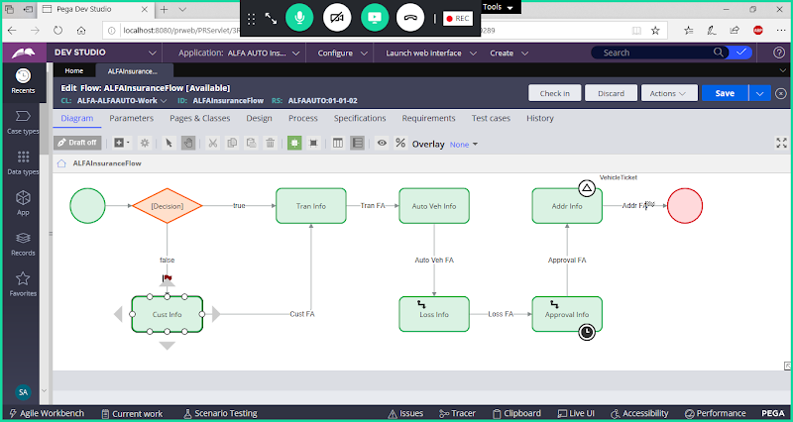

**=====**

**How to Create Srceen Flow:**

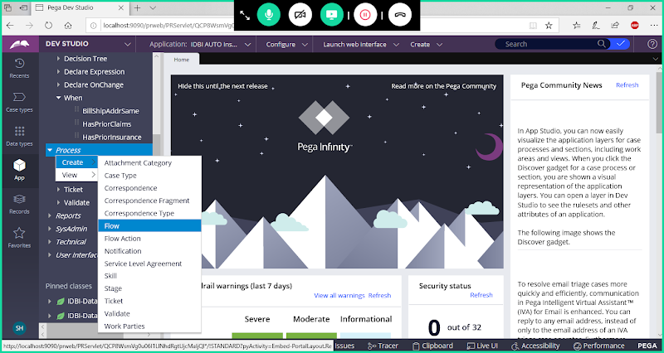

**Add Label**

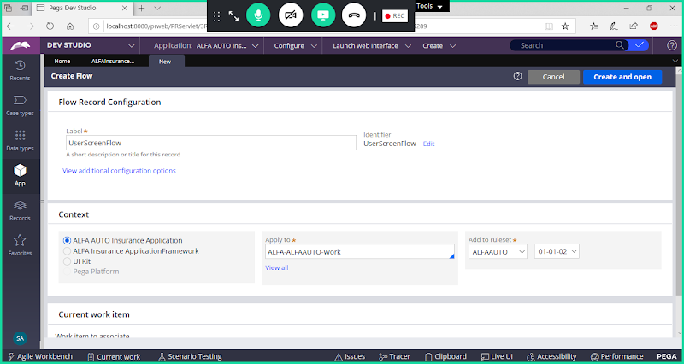

**Click on View  Additional Configuration Options**

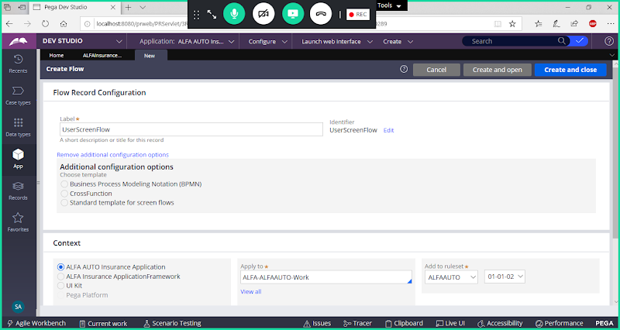

**Choose Template:  Standard template for screen flows**

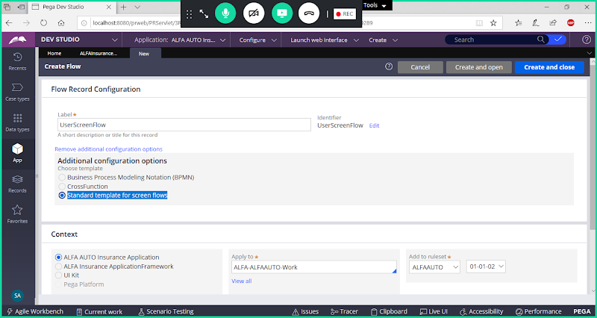

**Open**

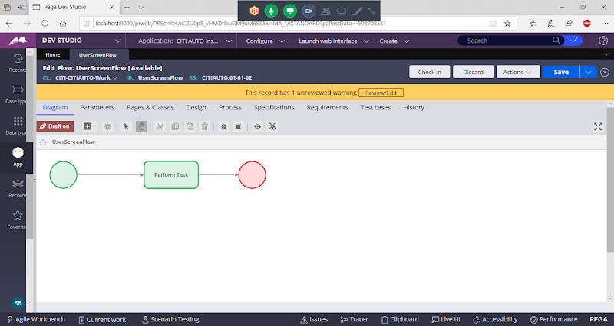

**Delete Default Assignment**

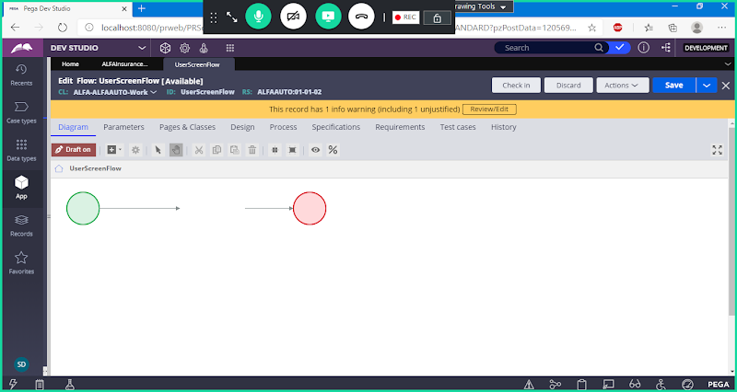

**Manually Add 3 Assignments**

**Add Decision Shape:**

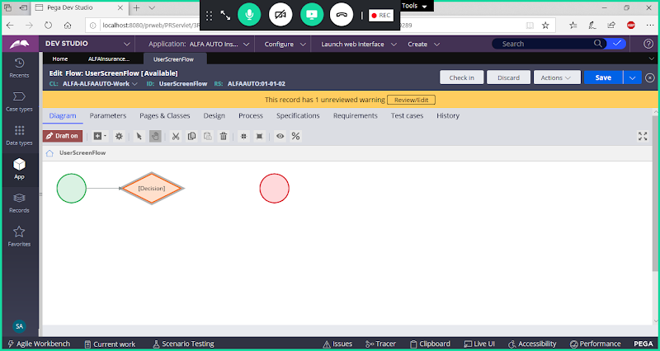

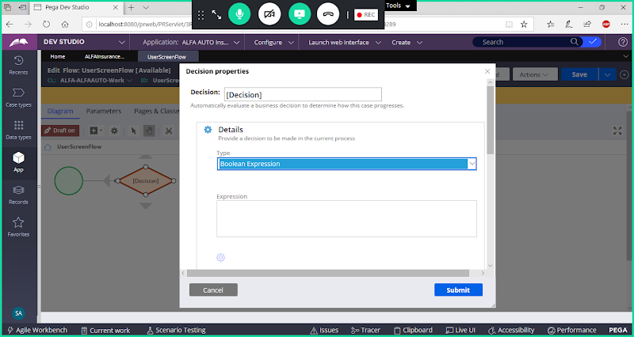

**Add Decision Condition using Expression Builder**

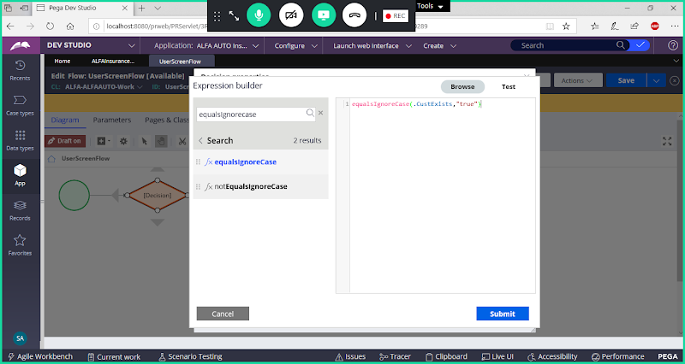

**Submit**

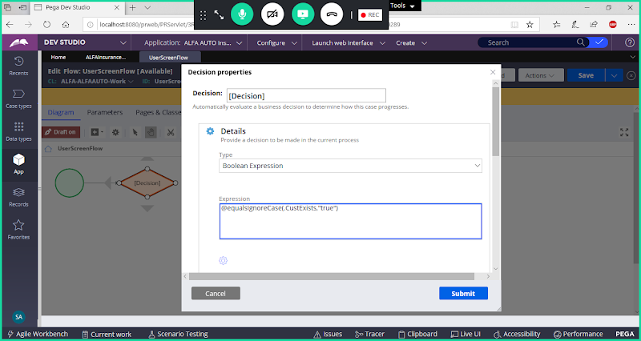

**Submit**

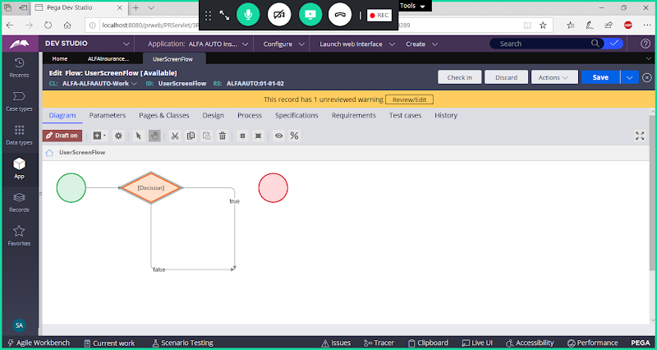

**After Decision Making, Add Assignment Shapes**

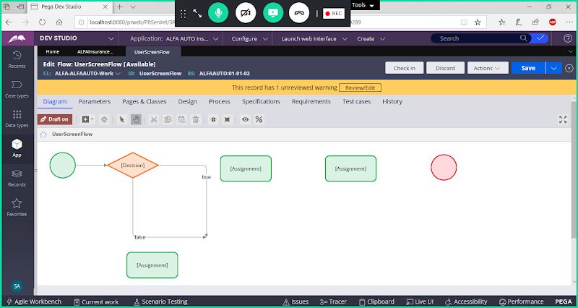

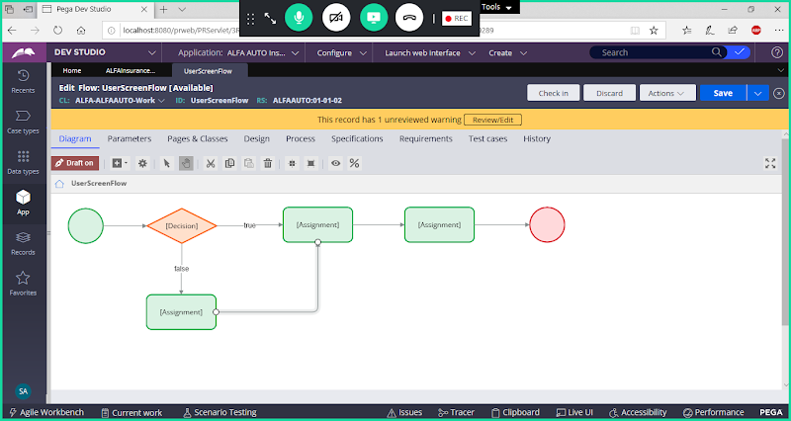

**Open True Connector Settings & Submit**

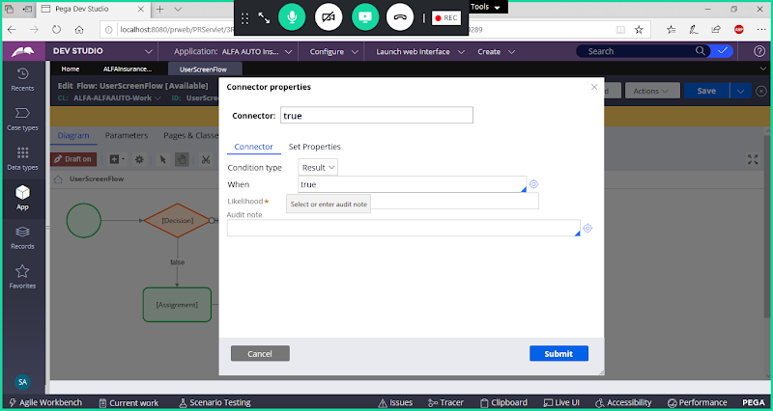

**Open False Connector**

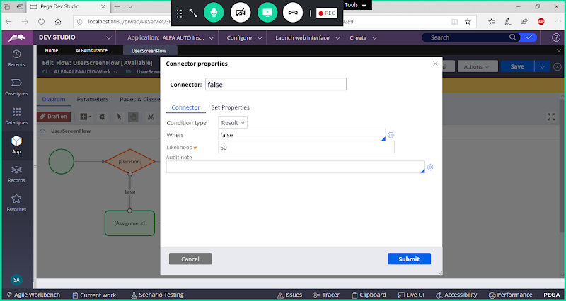

**Change Result type to Else**

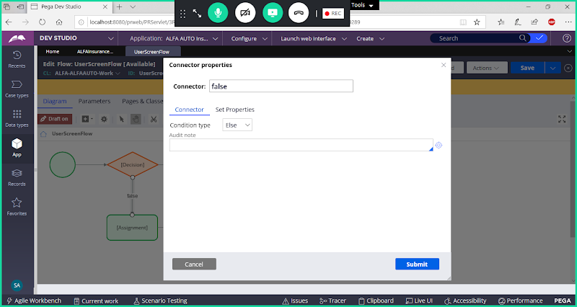

**Submit**

**===**

**Now Add Flowaction Names Under Assignment**

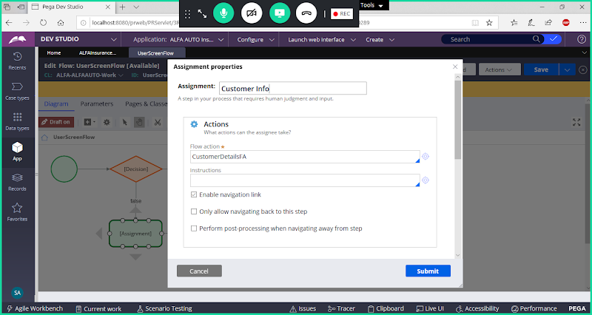

**Similarly map remaining 2 assignments ( Transaction & Vehicle )**

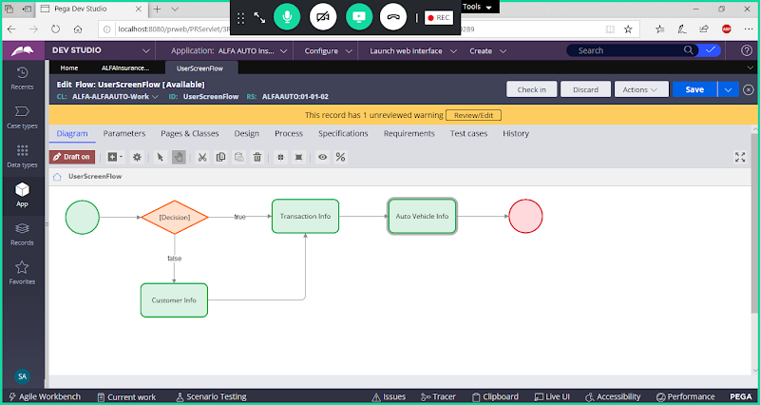

**How to Add Routing in Screen Flow:**

**Double click on Start Shape properties & Scroll Down**

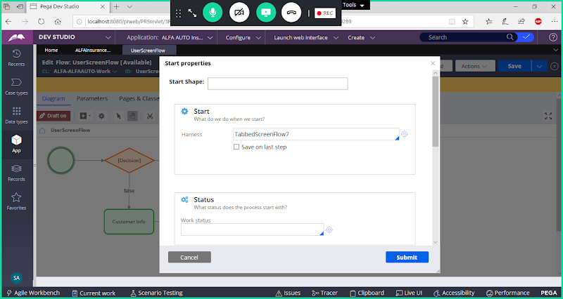

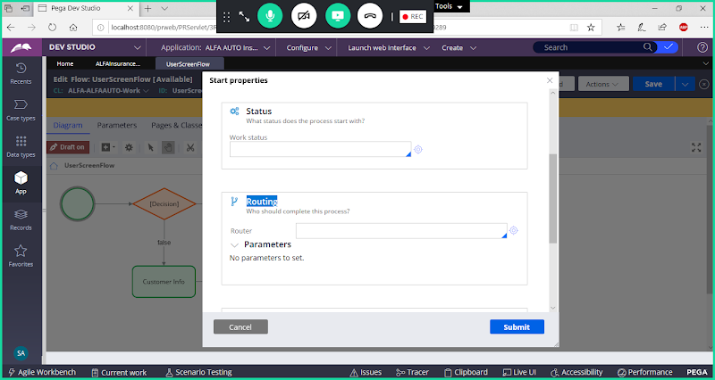

**Route Screen flow to User Portal ID: ALFAUSer**

**Now Open Screen flow start shape settings & Add Routing**

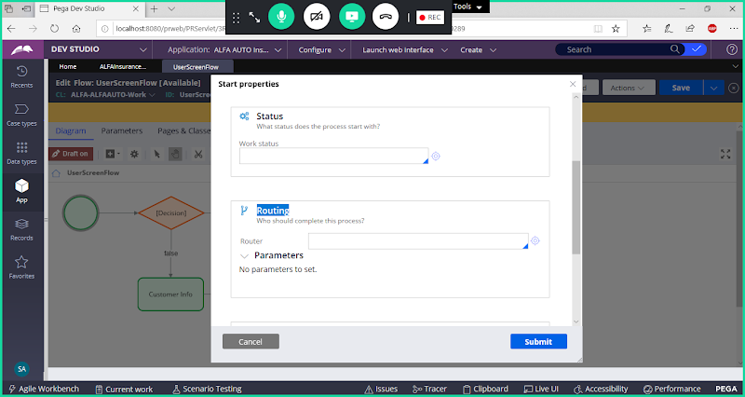

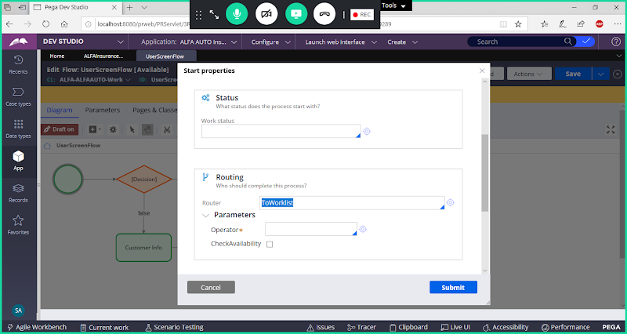

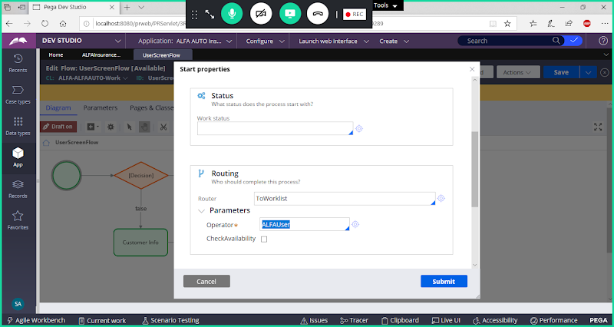

**Submit & Save Screen flow**

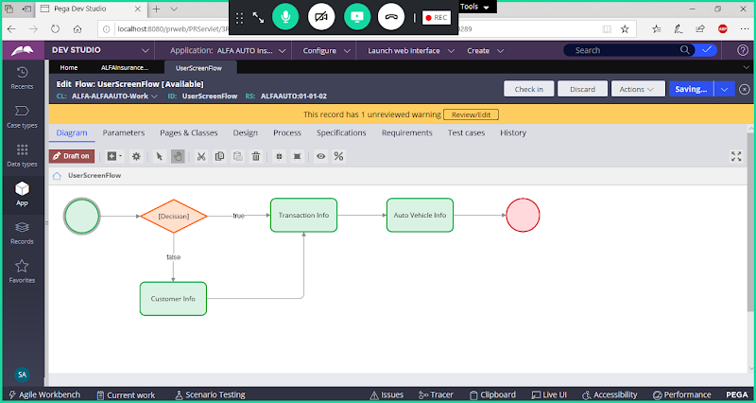

**Call Screen flow in Insurance Process flow using Sub-Process Shape**

**Open Insurance Flow & Customize**

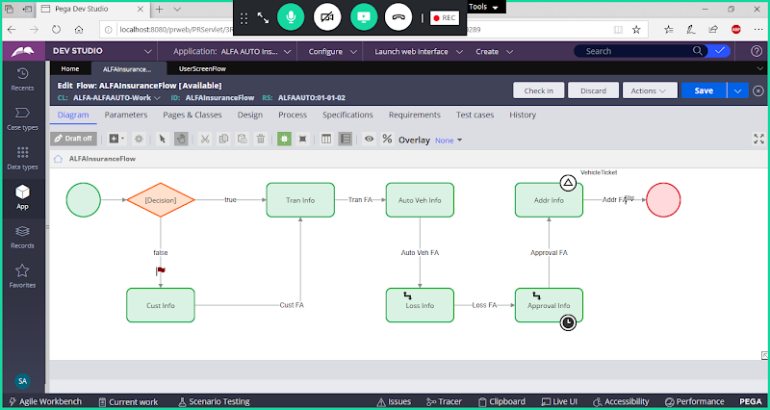

**Now Redesign Process Flow.  Add Subprocess & Call SCreen flow**

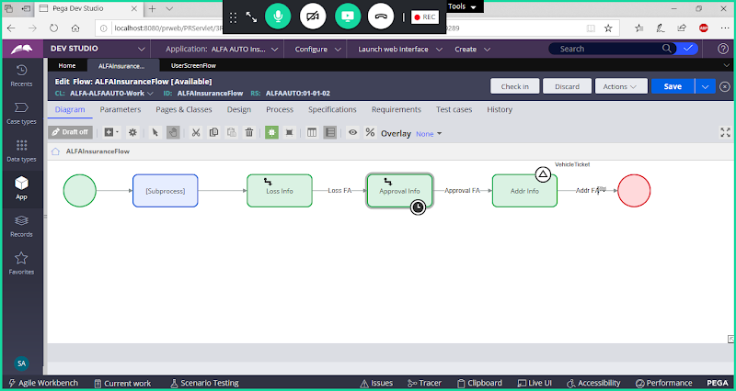

**Double Click on Sub Process & Call Screen flow**

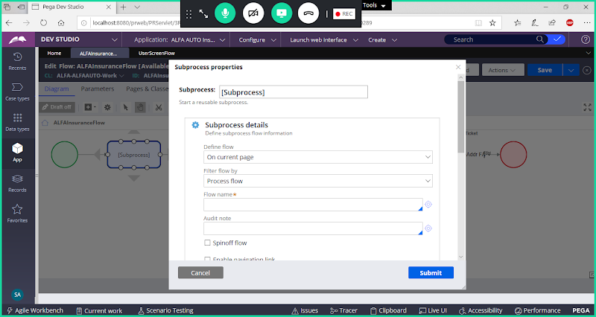

**Filter Flow Type: Select Screen flow**

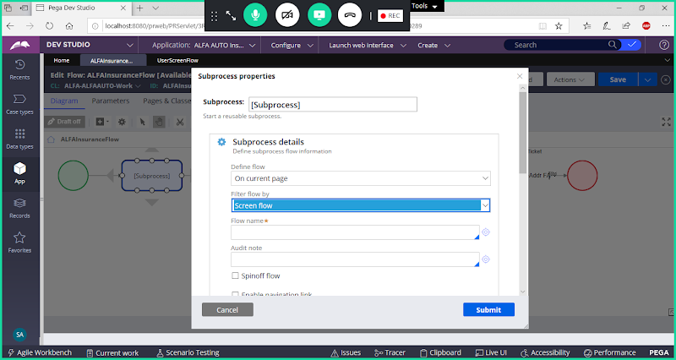

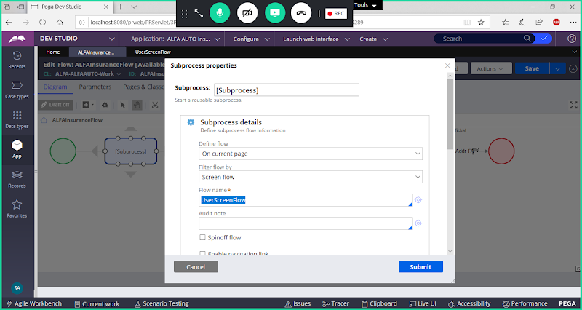

**Submit**

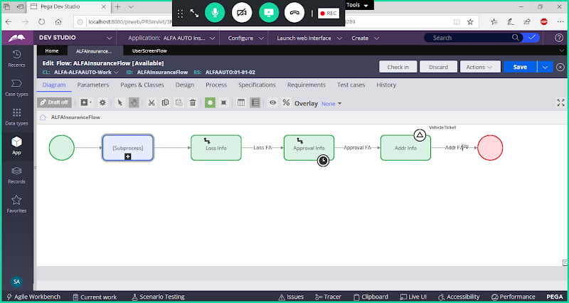

**Save Insurance Flow &  Run the Flow**

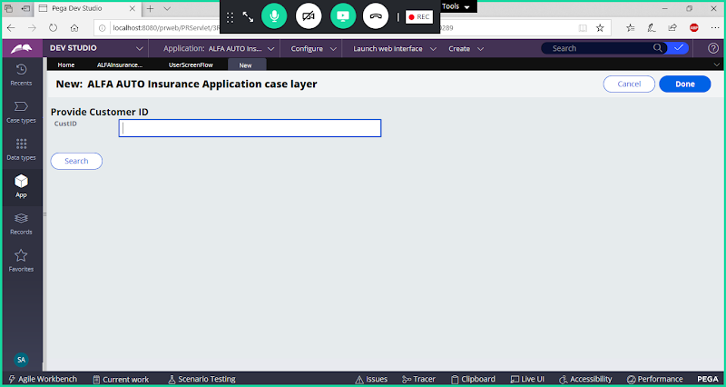

**Click on Done**

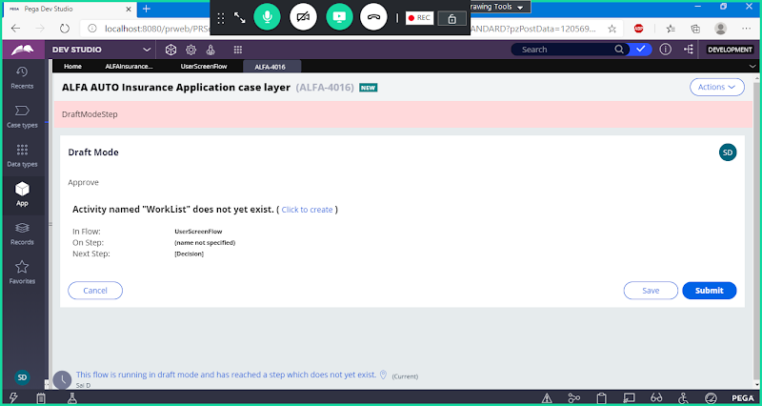

**Click on Submit**

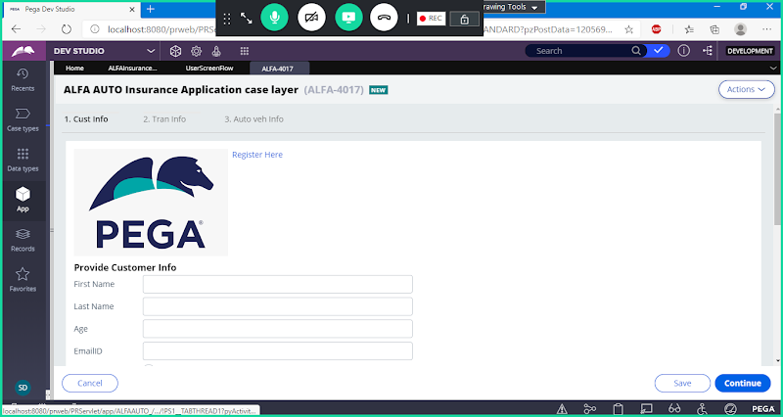

**Click on Continue**

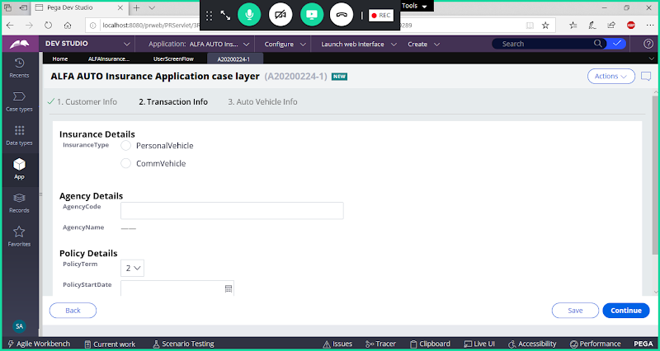

**Click Continue**

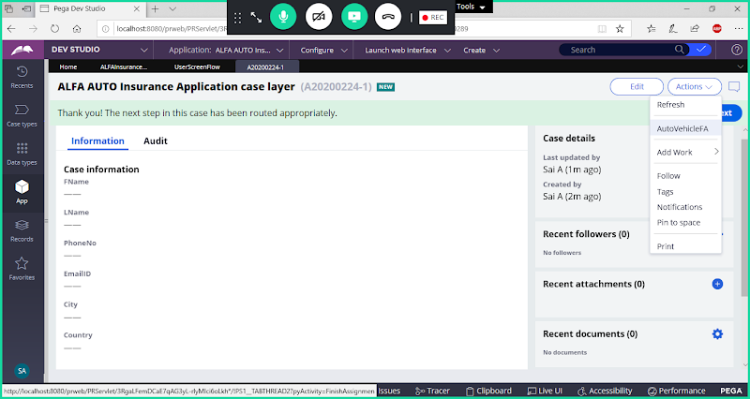

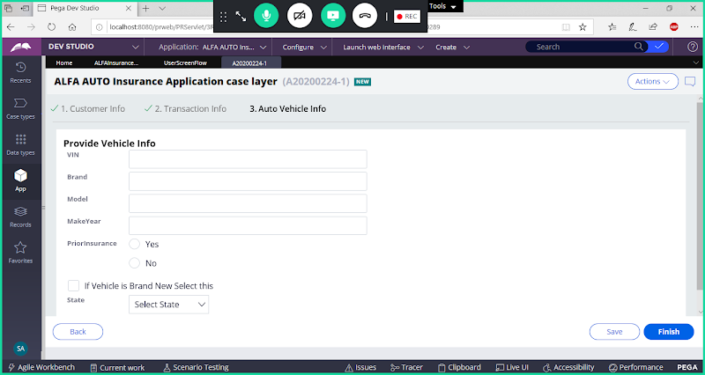

**Click on Finish , So Screen flow steps are Completed. Now Select LOSS Assignment from Actions Dropdown, similarly complete remaining  steps in Process flow.**

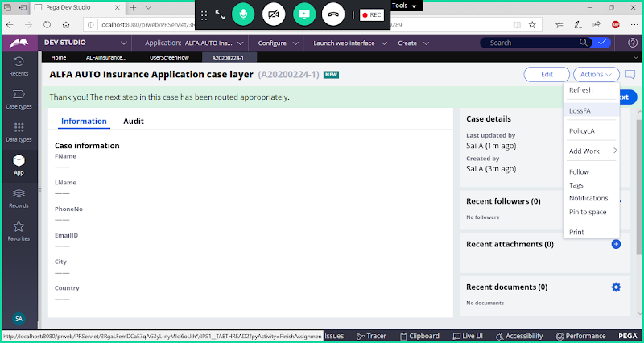

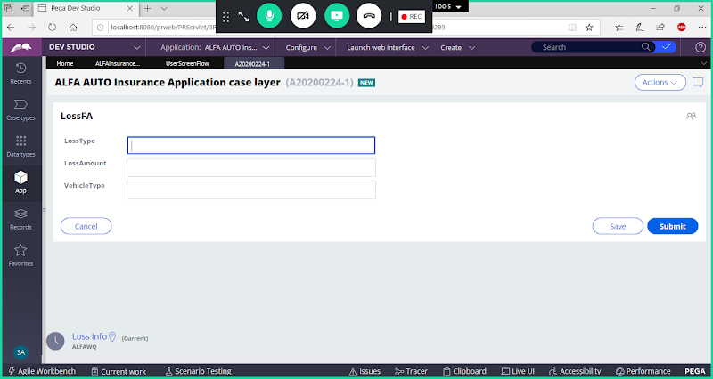

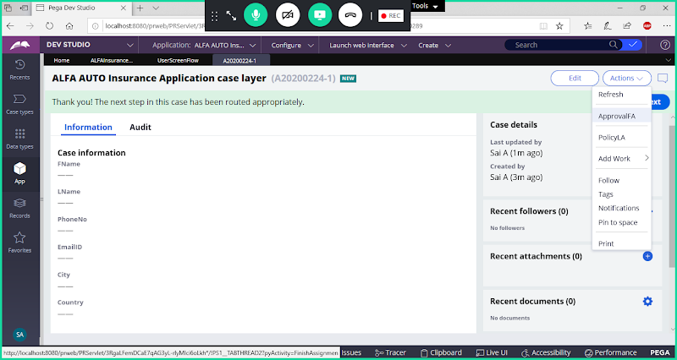

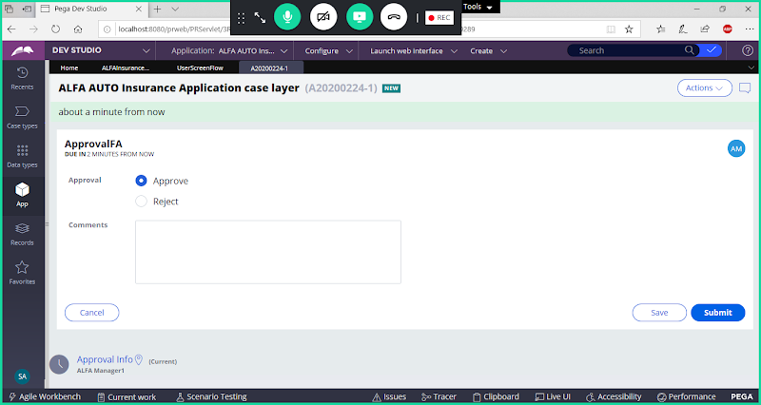

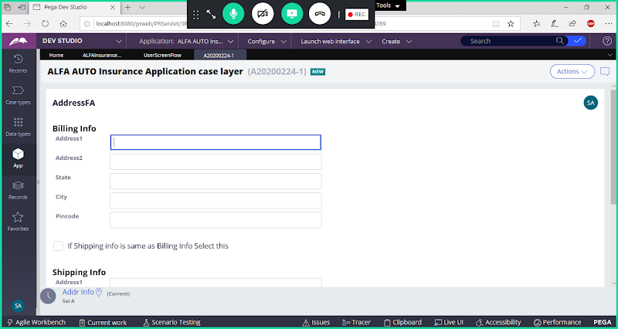

**========================================**

**Now Remove Routing in Start shape properties of Screen flow & Run Flow again.**

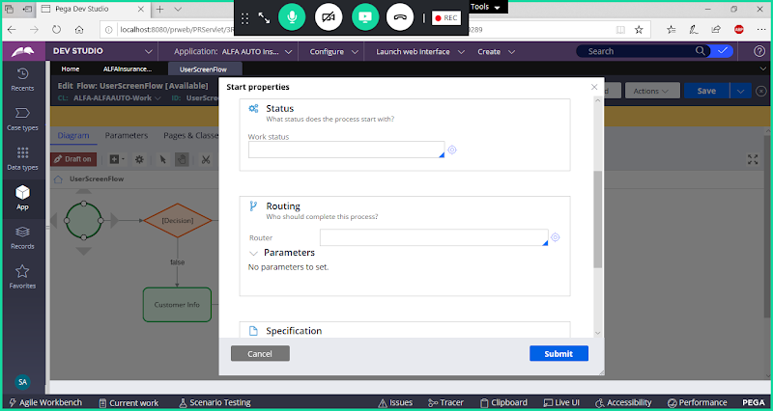

**Submit & Save Screen flow**

**----------------**

**Spinoff Flow/ Spin off Flow in Sub Process shape Properties**

**Open subProcess shape Properties:**

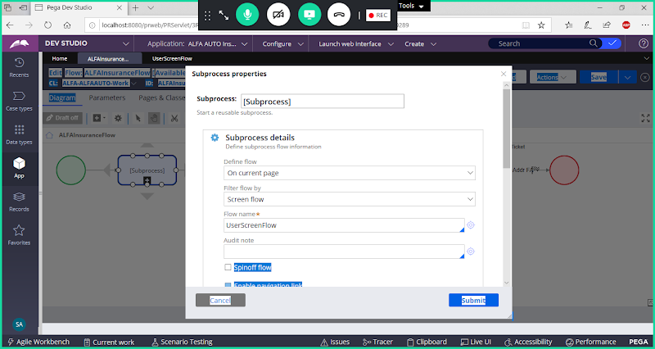

**Select Spin Off Option**

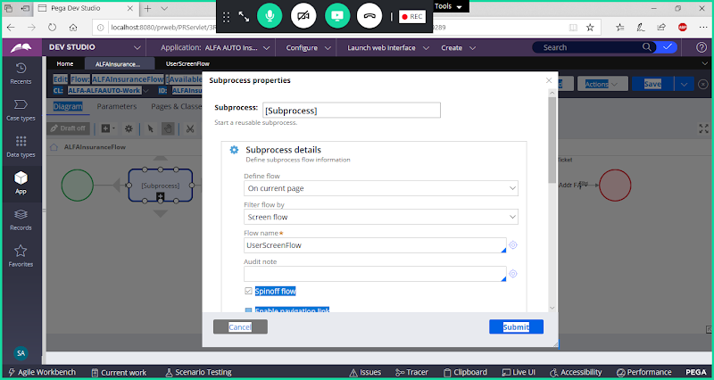

**Submit , Save**

**Run Process Flow:**

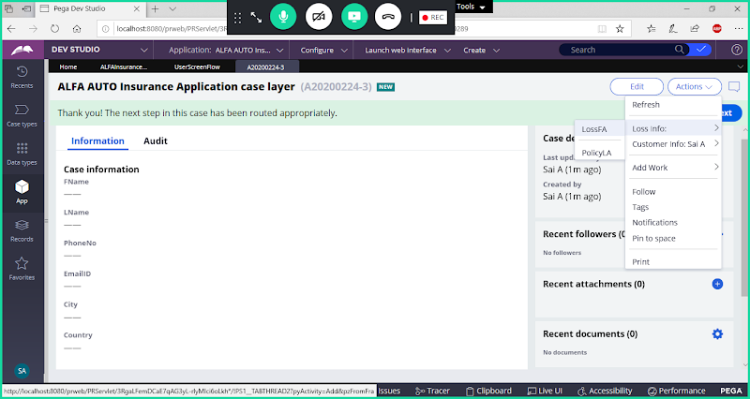

**You can complete process flow first, later you can complete screen flow steps or Vice Versa.**

**Spin Off Flow Check Box Option:**

**Check Box Selected: We can complete Process Flow First & Later Process Screen Flow Steps or Vice Versa, we can complete execution of Process flow without completing screen flow. This is Asynchronous behaviour.( Not Parallel Execution, but one after another)**

**Check Box Not Selected(default): After Calling Screen flow, remaining steps in the Process flow gets executed. This is Synchronous Behaviour**

**=========================**

**About Save on Last Step option in Screen Flow Start Shape Properties:**

**Open Screen flow -> Start Shape Properties:**

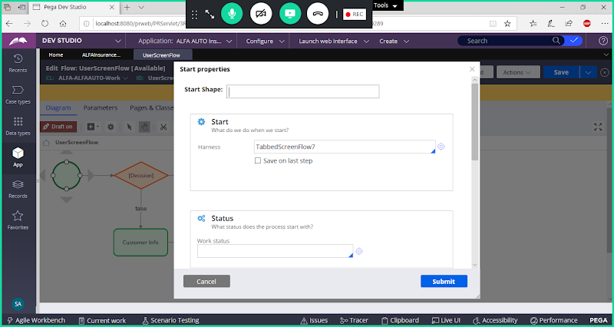

**Enable Save on Last Step in screen flow:**

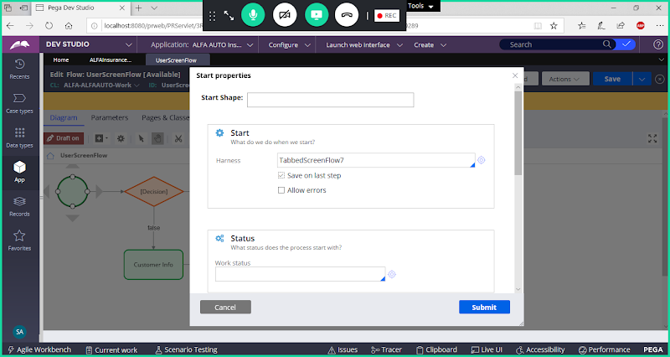

**Submit & Save screen flow**

**Check Box is Selected: If we select the Check box Save will happen, but commit will happen at end of screen flow**

**Check Box not Selected( Default):  Save & Commit will happen after every step/Assignment**

**=================**

**Types of Screen flows / Screen Flow Templates:**

**1. Tabbed Screen flow7**

**2. Tree Navigation7**

**3. Perform Screen flow**

**We can Change Screen flow Type from Start shape Properties: ( From Harness Option we can Change)**

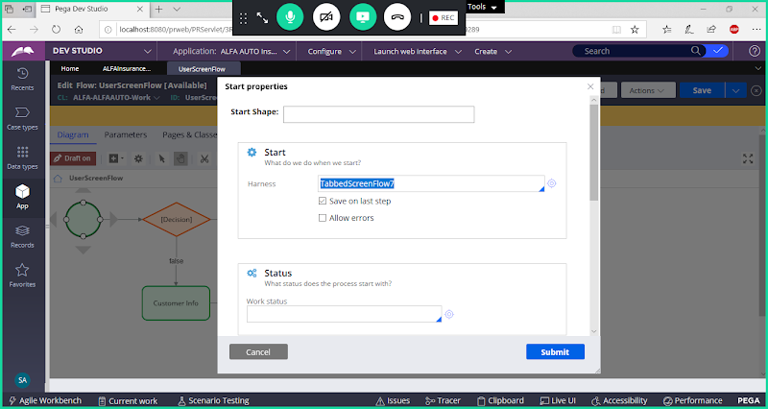

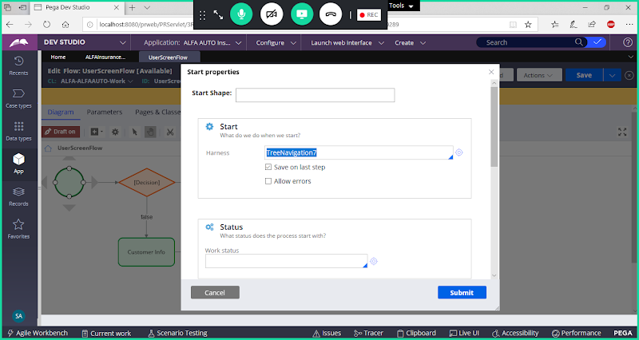

**Submit**